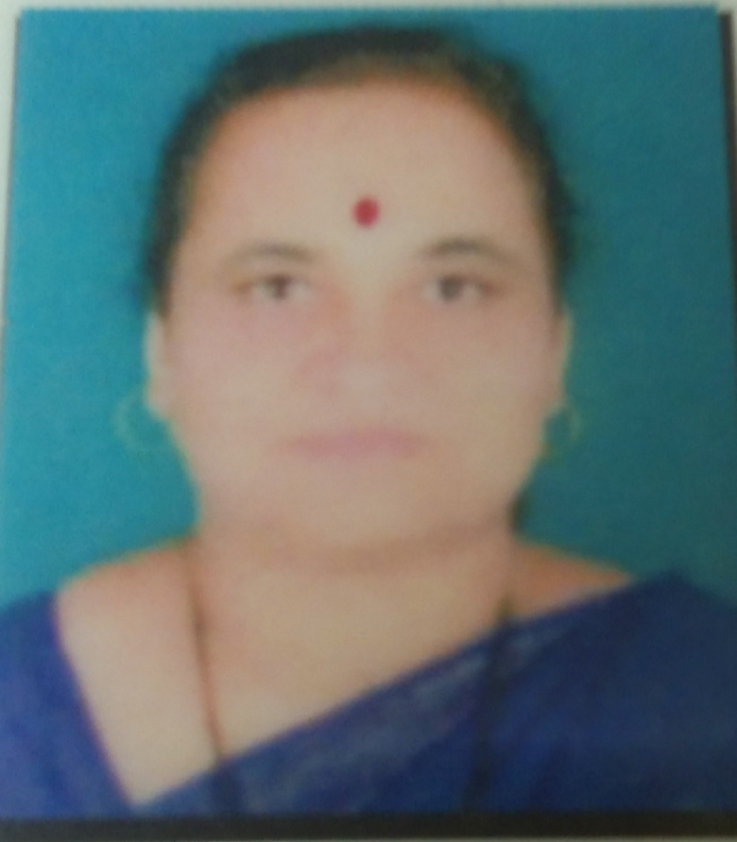

Faculty Profile
General Information:
1. | Name | : | Mrs.Gaikwad Rajashri Dattatraya
2. | Fathers/Mothers Name | : | Shri.Krishnarao Ganpati Bhagade
3. | Department | : | English
4. | Current Designation | : | Assistant Professor
5. | Date of Last Promotion | : | 20 /07 /2016
6. | Address for Correspondence | : | Chhatrapati Shivaii College, Satara
7. | Permanent Address | : | A/P- Pachwad, Tal – Wai, Dist- Satara,
 |  |  | Mobile No. : 9423342082
 |  |  | Email:
8. | Whether acquired any degrees or
 | fresh academic qualification during | : | No
 | the year
  - Academic Staff College Orientation/ Refresher Course Attended during the Year : No
  - Date of Appointment: 20/07/2006
- Academic Qualifications:

Examina | Name of the | Year of | Percentage | Division/ | Subject
tion | Board/ | Passing | of | Class/ Grade
 | University |  | Marks
 |  |  | obtained
S.S.C | Kolhapur Board | 1985 | 53.57% | Second | Mar, Hin., Eng., Science,
 |  |  |  |  | Maths, Soc. Science
H.S.C. | Kolhapur Board | 1987 | 66.50% | First | Mar, Hin, Eng, Soci,
 |  |  |  |  | History, Eco.
B.A. | Shivaji | 1990 | 63.33% | First | English
 | University,
 | Kolhapur
M.A. | Shivaji | 1992 | 55% |  | English
 | University, |  |  | Second
 | Kolhapur
M.Phil. | Shivaji University, Kolhapur | 2002 | - | ‘B’ | English
- Research Degree :

Degree | Title | Date of | University
 |  | Award
M.Phil. | ‘Arundhati Roy’s The God of Small Things : A Study | 09/07/2002 | Shivaji University,
 |  |  | Kolhapur

- Posts held after appointment at this institution :

Sr. | Name of the College | Designation | Nature of | From | To | Years
No |  |  | Appointment
1 | Yashwantrao Chavan Mahavidyalya, Pachwad | Assistant Professor in English | Permanent | 20/07/2006 | 16-06-2025 | 18 years
2 | Chhatrapati Shivaji College, Satara | Assistant Professor in English | Permanent | 17-06-2025 | Till today | 1month

- Academic Staff College Orientation / Refresher Course / ISTE – AICTE Sponsored STTP / SBP Attended :

Sr. |  |  | Name of the |  |  |  |  |  |  | Place |  |  |  |  | Period |  | Grade |  |  | Sponsoring
No |  |  | Course |  |  |  |  |  |  |  |  |  |  |  |  |  | Obtained |  |  | Agency
1 |  |  | Orientation |  |  |  |  |  |  | Jamia Milia |  |  |  |  | 13th April to 10th May, 2010 |  |  | ‘A’ |  | UGC
 |  |  |  |  |  |  |  |  |  | Islamia, New Delhi
2 |  |  | Refresher Course |  |  |  |  |  |  | Dr.Babasaheb Ambedkar Marathawada University,  Auragabad |  |  |  |  | ^{5th Aug. to 26th Aug. 2011} |  |  | ‘B’ |  | UGC
3 |  |  | Refresher Course |  |  |  |  |  |  | Sant Tukdoji Maharaj University, Amravati |  |  |  |  | 20th Nov. to 11th Dec.2012 |  |  | ‘A’ |  | UGC
4 |  |  | Refresher Course |  |  |  |  |  |  | Dr.Babasaheb Ambedkar Marathawada University,  Auragabad |  |  |  |  | 2nd Dec to 22nd 2014 |  |  | ‘A’ |  | UGC
5 |  |  | Faculty Development Program |  |  | Programa |  |  |  | Ramanujan Collge, University of Delhi |  |  |  |  | 2/7/2020 to 17/7/2020 |  |  | -- |  | UGC
6 |  |  | English Communication Training Program |  |  |  |  |  |  | Rajarshi Chhatrapati Shahu College, Kolhapur |  |  |  |  | 12/2/2021 to 9/7/2021 |  |  | - |  | Rayat Shikshan Sanstha, Satara
 | 7 |  | STC Progeamme |  |  |  |  |  |  | Departmment off Health Research Multidisciplinary Research Unit UP India |  |  |  |  | 20-0-2025 to  20-07-2025 |  |  |  | - | Science Tech Institute Lucknow UP India
❖ Specialization : |  |  |  |  |  |  | : |  |  | Indian English Literature
❖ Teaching and Research Experience: |  |  |  |  |  |  |  |  |  |  |  | 18 Years

RESEARCH EXPERINCE (Paper Presented):

Sr. No. | Title of the paper | Status  National/  International  /State | Organizer | Year
1 | Subjugation of Ammu in The God Of Small Things | National | Arts and Commerce College, Nagthane | 2013
2 | The theme of Violence in The Shadow Lines | National | Vivekanand College, Kolhapur | 2013
3 | Language and Discourse in The White Tiger | National | S.G.M.College, Karad | 2014
4 | ICT Use in Teaching Learning: A Study | National | Y.C. College, Pachwad | 2014
5 | Business Communication | National | D.G. College, Satara | 2014
6 | Need of Language Competency in Business Communication | International | D.G. College, Satara | 2015
7 | Reading as a Skill of Language Acquisition | National | C.S.College, Satara | 2015
8 | The Female Quest for Identity in Saina Nehwal’s Autobiography | National | S.M.S.M.P. Mahavidyalaya, Rahimatpur | 2016
9 | Image of Society in Last Man on Tower | National | Institute of Advanced Studies in English Aundh, Pune | 2016
10 | Feminism and Indian English Fiction | National | Y.C. College, Pachwad | 2016
11 | Nation Builders | National | M.H.Shinde Mahavidyalya, Tisangi | 2018
12 | Teaching Figures of  Speech in Poetry | State | Anantrao Thopte College, Bhor | 2018
13 | Balram, A Subaltern in Arvind Adiga’s The White Tiger | 3rd International Conference | Balwant College, Vita | 2021
14 | Feminist Presentation in The God of Small Things | International | Chhatrapati Shivaji College, Satara | 2025

RESEARCH EXPERINCE (Publications):

Sr. No.  RESEARCH EXPERINCE (Publications): | Title of the paper/Book (with page no.) | Status  National/ international/  state | Name of the Journal | Publisher | Year
1 | The Theme of Poverty and Corruption in Aravind Adiga’s  The White Tiger | International | Research Dimensions A Multi Disciplinary Peer-reviewed International Journal ISSN: 2249-3867 | L.B.P. Mahavidyalaya, Solapur | 2013
2 | ICT Use in Teaching Learning: A Study | International | Research Chronicler International Multidisciplinary Research Journal ISSN:2347-5021 | Y.C. College, Pachwad | 2014
3 | Role of Media in the Empowerment of Women | National | Challenges Before Women Emporment ISSN: 978-93-82028-71-0 | Y.C. College, Pachwad | 2015
4 | Research and Teaching Learning Process | National | Quality Enhancement in Teaching Learning and Evaluation ISSN: 978-81930466-1-6 | D.G. College, Satara | 2015
5 | Need of Language Competency in Business Communication | International | Contemporary Issues in Commerce Economics and Management Vol.2 ISBN 2394-207 | D.G. College of Commerce, Satara | 2015
6 | The Female Quest for Identity in Saina Nehwal’s Autobiography | International | Indian Women’s English Autobiographies: A Study in the Quest for Indentity ISSN 978-93-85- 882-05 | Harshawardhan publication Pvt.Ltd. Beed | 2016
7 | Politeness Strategy in Business Communication | International | International Journal of Multi-faceted & Multi-lingual Studies Vol. III (XII) ISSN (Print) 2394-207x | D.G.College of Commerce, Satara | Dec.  2016
8 | Subaltern Studies in The White Tiger | International | Research Chronicler International Multidisciplinary Research Journal ISSN:2347-5021 | - | 2015
9 | Feminism and Indian English Fiction | National | Social Movements in Post Independence India ISBN: 978-93-5254-328-1 | Y.C. College, Pachwad | 2016
10 | Scattered Old Values in ‘Last Man in Tower’ | International | JICRT-Vol.VI,Issue I, ISSN- 2320-2882 | JICRT-Vol.VI,Issue I,  www.jicrt.org. | 2018
11 | Nation Builders | National | Aayushi International Interdisciplinary Journal  ISSN-2349-638x UGC Approved No.64259 | M.H.Shinde Mahavidyalya, Tisangi | 2018
12 | Nature and Langauge in Amitav Ghosh’s in The Hungry Tide | International | Review of Research Vol-VII ,Issue -4, ISSN-2249-894x | Reviw of Resrearch www.jbp.world | 2018
13 | The Growth of Nationalism in India | National | Akshada Multidisplinary Research Publication Peer-Reviewed & Referred International Research Journal 5.54 | Dr. Patangrao Kadam Mahavidyalya, Ramanandnagar | 2021
14 | Feminism in Girish Karnard’ Nag-Mandala | International | JETIR Nov.2021, Vol-8 Issue-11 | JETIR Nov.2021, Vol-8 Issue-11 | 2021
15 | Feminist Presentation in The God of Small Things | International | Research Chronicler Journal | ISSN: 247-503X | 2025

RESOURCE PERSON:

Sr. No. |  | Details  (Guest Lecture/Resource Person/Key-note speaker/chairperson) |  |  | Status  National/  International/  State | Organizer | Year
1 |  | Chairperson of a plenary Session in the One Day Teacher’s Workshop on Revised Syllabus of English B.Com II |  |  | State | Dahiwadi College, Dahiwadi. | 2014
2 |  | Chairperson of Paper Presentation Session in UGC sponsored two day national conference in English on ‘Communication Skills in Era of the Globalization’ |  |  | National | Dhananjayrao Gadgil College of Commerce, Satara | 2014
3 |  | Chairperson of valedictory function in University Level Teacher’s Workshop on Revised Syllabus of English Compulsory B.A.III |  |  | State | Dahiwadi College, Dahiwadi. | 2015
4 |  | Chairperson of Paper Presentation Session in one day national seminar on ‘Creative Ways of Teaching Language & Literature’ |  |  | National | Venutai Chavan College, Karad. | 2015
5 |  | Expert Lecture on ‘Linguistics Changes after Covid-19’ |  |  | State | Yashwantrao Chavan Mahavidyalya, Pachwad | 2020
 | ❖ Research Contribution:
 | - Research Papers Published: 15
- Research Papers presented at International, National and State Level Seminars &

Conferences:14
- Recognition :

  - Permanent Recognition as a Post Graduate Teacher. (Subject -English) by Shivaji University, Kolhapur.

  - Permanent Recognition as Teacher for M.Phil Paper (Subject English) by Shivaji University, Kolhapur.
- Membership of Academic Bodies:

    - Life Member: Shivaji University English Teachers Association
    - Member of College Development Committee
    - Coordinator of Internal Examination Committee

    - Member: Shivaji University English Teachers Association
    - Member of IQAC,YCM, Pachwad (Coordinator of Criterion No. V) in 2021-2022
    - Coordinator of IQAC 2022-2024
    - Coordinator of Women Studies Centre and Women Development Committee
- ADMINISTARTIVE EXPERINCE:
Sr. No. | Name of the college | Committee | Designation (Chairman/ Coordinator, Secretary, Programme Officer) | Period
- Yashwantrao Chavan Mahavidyalaya, Pachwad |  | IQAC | Coordinator | 2022-23 to 2023-24
 |  | Internal Examination Committee | Coordinator | 2020-21
 |  | College Development Committee | Member | 2017-18 to 2024-25
 |  | TCS Training Committee | Coordinator | 2019-2020 to  2021-22

